

University of Toronto Mississauga

CSC207 Fall 2022

Design Document

AUTHORS

Raghav Kanda

Ahmed Mohamed

Justin Tran

Christopher Flores



GITHUB TEAM:

MAT102Survivors

GITHUB URL:

https://github.com/o8RaV/MAT102Survivors.git

November 12 2022

**Contents**

| **S.No** | **Topic** | **Page Number** |
| --- | --- | --- |
| **1** | **Title Page** | **1** |
| **2** | **Project Identification** | **2** |
| **3** | **User Stories** | **3** |
| **4** | **Software Design** | **7** |
| **5** | **Expected Timeline** | **9** |

**Project Identification**

For this project, we will be building off Assignment 1. Specifically, we will be adding

various features to the Boggle game that will make it more interesting and accessible

to people who may need it. We have a variety of reasons for doing this project. For one, we noticed that the Boggle game that was finished in Assignment 1 is not implemented in a practical way. In particular, the user needs to play using the IDE’s console, which is not ideal for them to get a fulfilling experience with the game. After all, most computer games utilize an attractive GUI, which does not require the user to open some IDE. Second, we think that the current version of the Boggle Game should have more features in terms of gameplay. We believe this will make the game more fun since it allows users to customize how they want to play. Finally, the current version of the Boggle game does not provide additional support to people with disabilities. For example, people that have visual impairments may not be able to see the Boggle grid provided in the IDE console that well, or they may not be able to even see it at all. So, we plan on implementing a GUI and an audio interface that will exemplify accessibility features. The User Stories, Software Design, and Expected Timeline to help achieve these goals will be outlined in this document.

**User Stories**

Ahmed Mohamed

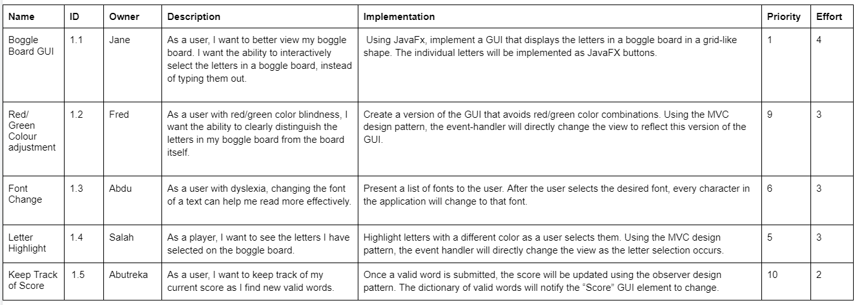

Raghav Kanda

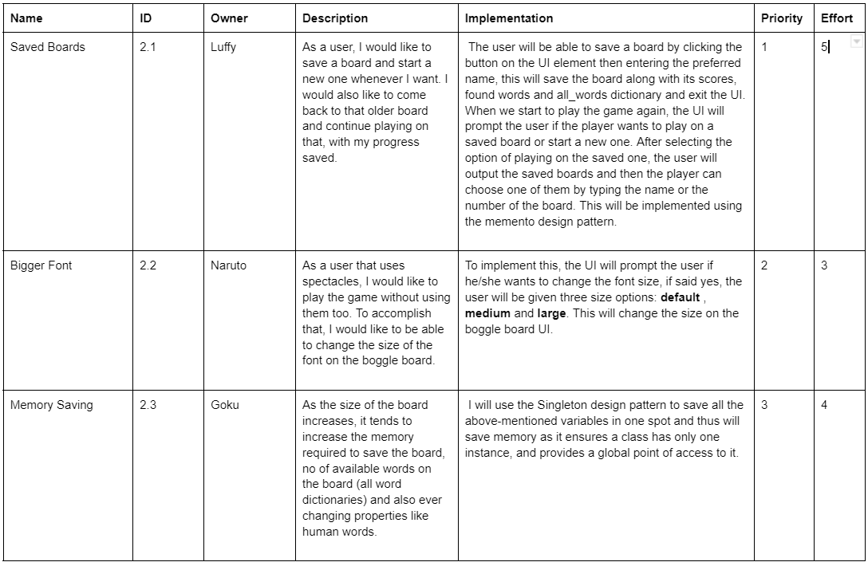

Justin Tran

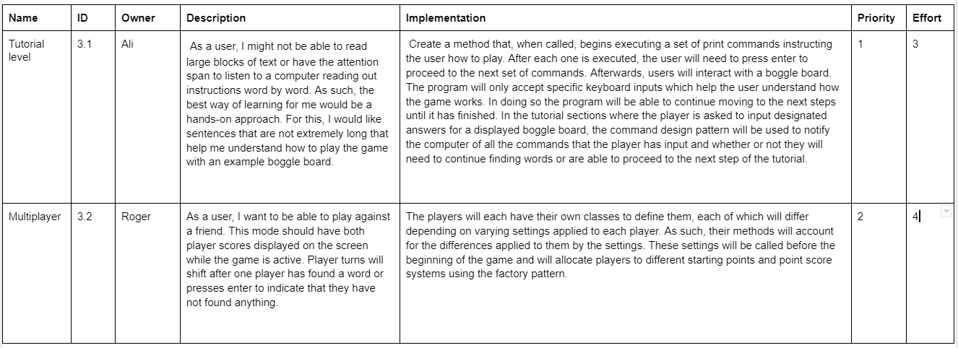

Christopher Flores

